Contents

**History of Eid ul-Fitr** 1

**Introduction** 1

**Historical Background** 1

**1. Origin During the Prophet Muhammad’s Time (PBUH)** 1

**2. The Significance of the First Eid** 2

**3. Islamic Teachings and Sunnah of Eid** 2

**4. Cultural and Global Spread** 2

**Conclusion** 3

**History of Eid ul-Fitr**

**Introduction**

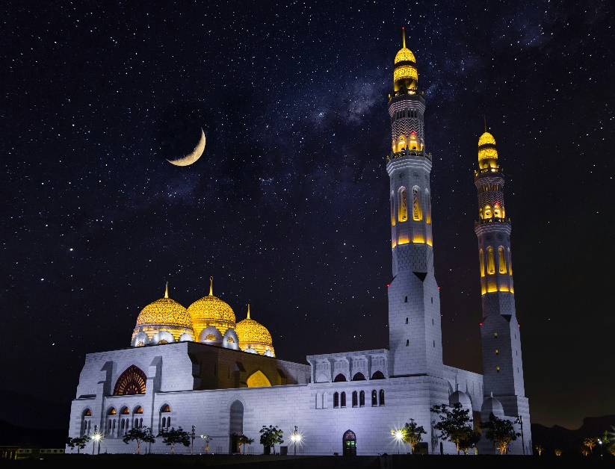Eid ul-Fitr, also known as the "Festival of Breaking the Fast," is one of the most significant religious holidays celebrated by Muslims around the world. It marks the end of the holy month of Ramadan, during which Muslims fast from dawn until dusk, dedicating themselves to prayer, self-restraint, and charity. Eid ul-Fitr is a day of joy, gratitude, and communal unity.

**Historical Background**

**1. Origin During the Prophet Muhammad’s Time (PBUH)**

Eid ul-Fitr was first celebrated by the Prophet Muhammad (peace be upon him) in the year 624 CE after the migration to Medina. It came as a divine gift to Muslims after a month of fasting and spiritual devotion.

**Key Points:**

* Introduced after the first Ramadan in Medina.
* Allah revealed the command to fast in Ramadan in 2 AH (After Hijrah).
* Eid was established as a day to express gratitude to Allah.

**2. The Significance of the First Eid**

After fasting the whole month of Ramadan, the early Muslims were commanded to celebrate Eid with a special congregational prayer and charitable giving. The celebration was a contrast to the pre-Islamic festivals and was meant to reflect Islamic values of peace, community, and equality.

**Key Points:**

* First Eid included Eid prayer in congregation.
* Zakat al-Fitr (charity) was made obligatory before the prayer.
* Emphasis on unity, sharing, and care for the poor.

**3. Islamic Teachings and Sunnah of Eid**

Eid ul-Fitr is rooted in the Sunnah (traditions) of the Prophet Muhammad. It emphasizes prayer, charity, forgiveness, and joy. The Prophet encouraged Muslims to dress well, greet one another warmly, and come together as a community.

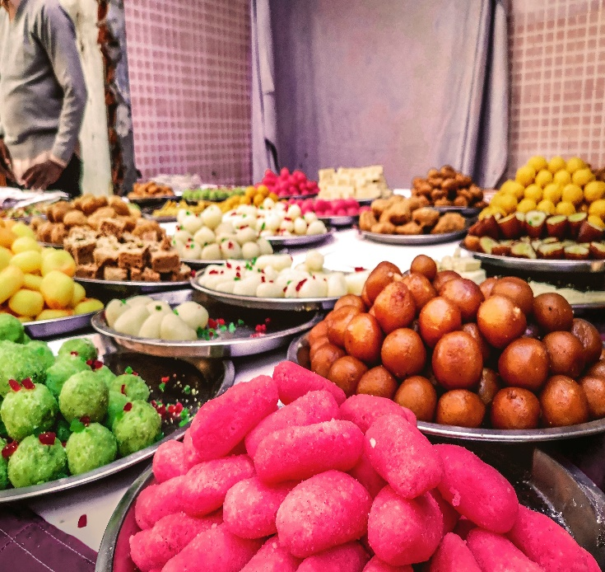**Key Points:**

* Two Rak'ahs of Eid prayer are performed in congregation.
* The khutbah (sermon) is delivered after the prayer.
* It is Sunnah to eat something sweet before the Eid prayer.
* The takbeer (saying “Allahu Akbar”) is recited on the morning of Eid.

**4. Cultural and Global Spread**

As Islam spread across the world, Eid ul-Fitr also began to be celebrated in various cultures, each adding unique traditions while preserving the core religious values. Today, Muslims in different regions celebrate with regional dishes, clothing, and customs, but the essence of faith and gratitude remains constant.

**Key Points:**

* Celebrated by over a billion Muslims globally.
* Diverse cultural customs: food, clothes, and local festivals.
* Maintains Islamic teachings of prayer and charity worldwide.

**Conclusion**

Eid ul-Fitr is a deeply spiritual and historical celebration that began over 1,400 years ago. It stands as a testament to Muslim unity, devotion, and compassion. From the time of the Prophet Muhammad to the present day, Eid ul-Fitr continues to serve as a joyful conclusion to Ramadan and a reminder of the values of faith, community, and gratitude.

**References**

1. **The Holy Qur’an**
   * Surah Al-Baqarah (2:183-185) – Verses that introduce the obligation of fasting during Ramadan.
2. **Hadith Collections**
   * Sahih al-Bukhari and Sahih Muslim – Various Hadith about the first Eid and practices of the Prophet Muhammad (PBUH).
   * Example: Sahih al-Bukhari, Book of Eid Prayers (Kitab al-Eidayn).
3. **Al-Mubarakpuri, S. R.** (1996). *Ar-Raheeq Al-Makhtum (The Sealed Nectar)*. Darussalam Publishers.
   * Biography of the Prophet Muhammad that includes early Islamic practices, including Eid celebrations.
4. **Esposito, J. L.** (2003). *The Oxford Dictionary of Islam*. Oxford University Press.
   * Offers background on Eid ul-Fitr and Islamic traditions.
5. **Nasr, S. H.** (2003). *Islam: Religion, History, and Civilization*. HarperOne.
   * Provides an overview of Islamic rituals and festivals including Eid.
6. **Peters, F. E.** (2003). *Islam: A Guide for Jews and Christians*. Princeton University Press.
   * Discusses Islamic practices such as Ramadan and Eid from a comparative perspective.